**Excel Assignment - 17**

1. **What are modules in VBA and describe in detail the importance of creating a module**

A VBA module is a container for storing your VBA code. It can be one of the following types:

* A standard VBA module: It holds VBA code for macros created by the macro recorder and procedures written by you. The procedures in the module can be called by procedures in other modules (including the other four types of module that to be discussed below) if they are declared as public by using the Public keyword. I discuss procedures later in Chapter 3.

* A workbook module: By default, it is named ThisWorkbook. One workbook has only one workbook module. It holds VBA code for workbook-level events. An event is an action initiated either by users or by other VBA code which triggers VBA to execute an event Sub procedure (also known as event-handler procedure or simply event handler). An event handler is written by you. Opening a workbook, before closing a workbook, changing a selection on a worksheet, and clicking a command button are examples of events.
  + A workbook module can also hold VBA code for other procedures written by you.

* A sheet module: It holds VBA code for event handlers that response to the events associated with a particular sheet in a workbook. Each sheet (either a worksheet or a chart sheet) has its own sheet module. A sheet module can also hold VBA code for other procedures.

* A UserForm module: A UserForm is a custom dialog box that you build to collect information from users. A UserForm module contains a UserForm and event handlers that response to the events related to the UserForm. It can also hold VBA code for other procedures. In a workbook, it can have more than one UserForm module, with one UserForm in each of these modules.

* A class module: It is used to create your own new class – a template to create an instance of an object at runtime. The VBA code that defines properties, methods, and events for a new class is stored in this module. I consider class module is an advanced topic and it is beyond the scope of discussion in this site.

In this chapter, you are going to see some sample procedures in each of these modules (except the class module). They are only simple procedures and of course many more can be created in those modules. Nevertheless, the samples do provide you the ideas in which module you should place your VBA code, and provide you the reasons why the code listings in this site are stored in certain modules. If you study some sample code listings from other references, such as books and the Internet, you should find no exception in where VBA code should be stored.

**2.What is Class Module and what is the difference between a Class Module and a Module**

* A class module: It is used to create your own new class – a template to create an instance of an object at runtime. The VBA code that defines properties, methods, and events for a new class is stored in this module. I consider class module is an advanced topic and it is beyond the scope of discussion in this site.

**3.What are Procedures? What is a Function Procedure and a Property Procedure**

**A procedure is a block of Visual Basic statements enclosed by a declaration statement (Function, Sub, Operator, Get, Set) and a matching End declaration. All executable statements in Visual Basic must be within some procedure.**

A Function procedure is a series of Visual Basic statements enclosed by the Function and End Function statements. The Function procedure performs a task and then returns control to the calling code. When it returns control, it also returns a value to the calling code.

**A property procedure is a series of Visual Basic statements that manipulate a custom property on a module, class, or structure. Property procedures are also known as property accessors.**

**5. What is a sub procedure and what are all the parts of a sub procedure and when are they used**

**A Sub procedure is a series of Visual Basic statements enclosed by the Sub and End Sub statements. The Sub procedure performs a task and then returns control to the calling code, but it does not return a value to the calling code.**

**are all the parts of a sub procedure are:**

* Sub statement.
* Name.
* Parentheses.
* End Sub keyword.

**6. How do you add comments in a VBA code? How do you add multiple lines of comments in a VBA code**

Steps you need to follow to add a comment in a VBA code:

1. First, **click on the line** where you want to insert the comment.
2. After that, **type an APOSTROPHE** using your keyboard key.
3. Next, **type the comment** that you want to add to the code.
4. In the end, **hit enter** to move to the new line and the comment will turn green.

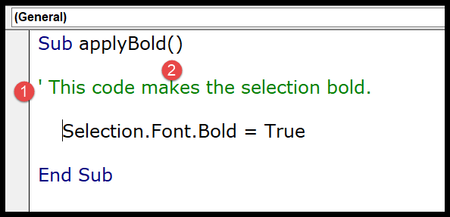

**In order to display this button, you need to add it: View -> Toolbars -> Edit. Now you can see two buttons in the toolbar: Comment block and Uncomment block. Simply highlight your desired line(s) of code and click one of the buttons. This will comment/uncomment entire lines.**